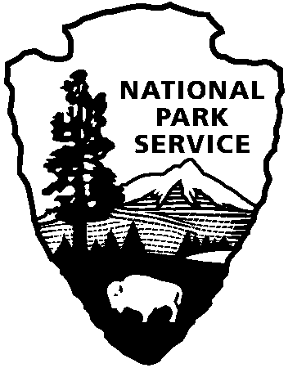

National Capital Parks - East
1900 Anacostia Drive SE
Washington, D.C. 20020
https://www.nps.gov/pisc/index.htm

(202) 690-5185
National Park Service
U.S. Department of the Interior

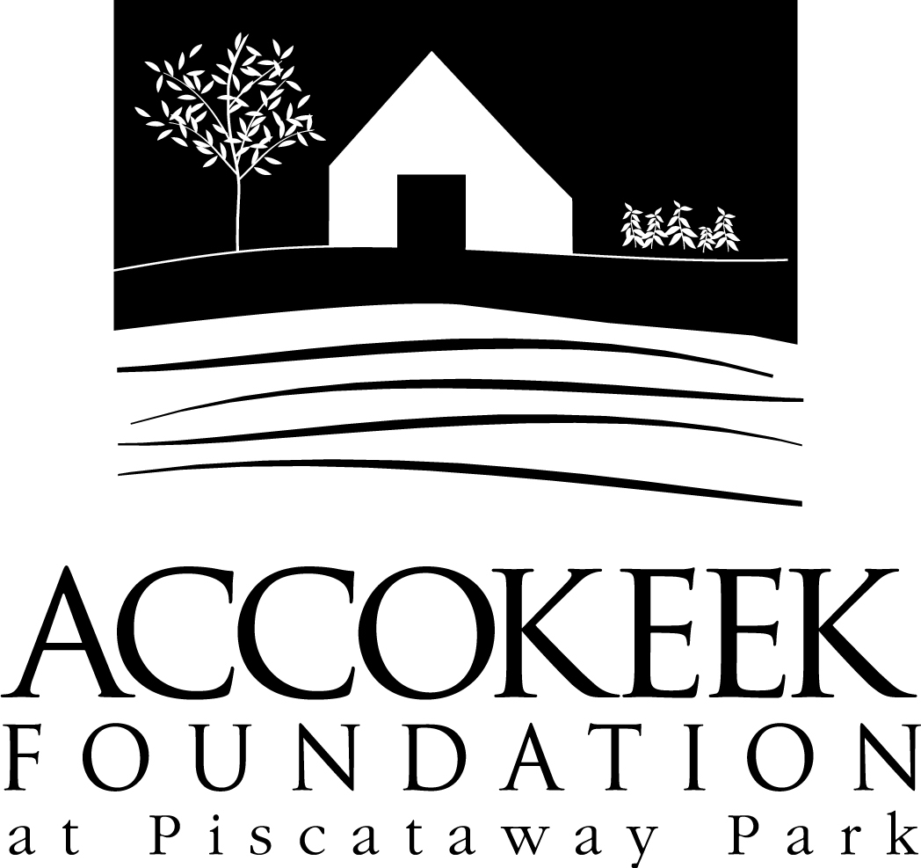

Position Title: Special Events Team

About the Foundation:
By blending history, ecology, economics and conservation, the Accokeek Foundation strives to teach land stewardship and sustainable use of natural resources, as well as interpret the natural and cultural heritage of the Tidewater Potomac. The foundation’s mission is to cultivate passion for the natural and cultural heritage of Piscataway Park and commitment to stewardship and sustainability. The National Colonial Farm and other Foundation activities exemplify the agricultural, preservation and conservation goals that are at the core of the Foundation’s mission and serve as an outdoor classroom to further the educational programs that are key to its success. In partnership with the National Park Service, the Accokeek Foundation stewards a 200-acre portion of Piscataway Park and preserves the view directly across the Potomac River from Mount Vernon.

About National Capital Parks - East:
The administrative National Park Service unit of National Capital Parks – East (NACE) contains thirteen park units and parkways, including Piscataway Park. The overall unit consists of 98 locations and more than 8,000 acres of recreation areas, historic homes, natural areas, farms, parkways, historic forts, archeological sites, and private properties. The sites provide important green and recreation space amongst dense urbanization and educate visitors through stories and the historical information related to the area.

About the Special Events Team:
Every year, the Accokeek Foundation holds several special events for the general public. These events include Latte’s with Lambs, Winter’s Eve, and Tails on Trails, among others. The events are held to offer general visitors a guided experience through our site, whether they are celebrating our incredible Heritage Breed Livestock or embracing 18th century holiday traditions. Volunteers serving on the Special Events Team will have the opportunity to enhance our general visitor experience through the event, while also connecting/reconnecting visitors to the wonders of Piscataway Park.

Position Summary and Purpose:
Special Events Volunteers support the preparation, delivery, and cleanup of our large park events. Event service assignments typically involve engagement with the general public. Volunteers will serve alongside foundation employees to provide quality experiences and programming to visitors, while also ensuring a safe learning environment.

Responsibilities may include:

- Event preparation prior to event date
- Event set up (day of) and/or takedown (day of)
- Admissions sales and visitor counting
- Food sales
- Parking supervision/guidance
- Activity supervision
- Demonstration of a skill/craft
- Musical performance

Qualifications:
No previous experience in working on special events is necessary. Training will be provided. The ability to follow detailed directions, work with a diverse visitor base, and strictly adhere to the customer service philosophy ‘visitors first’ is required. Prior experience with livestock handling, sheep shearing, 18th century music/crafts, visitor engagement, and sales/admissions is a bonus.

Time Requirements:
This position is very flexible. Regular volunteers are welcome in this position, but it is also perfect for one time volunteers or project groups. Event shifts can be filled with large groups or individuals, as needed. Volunteers must be available for at least one special event shift per year. Day of Event shifts are usually 6-7 hours in length. Other shift lengths vary.

Benefits:
Regular volunteers will receive a 10% discount at the museum gift shop and visitor’s center.

Volunteers will also be enrolled in the National Park Service – wide Volunteers – In – Park (VIP) program by signing Volunteer Service Agreements. The VIP program protects those volunteering on National Park Service land in case of accident or injury through the Federal Employees’ Compensation Act and the Federal Tort Claims Act. Additionally, for every 250 hours served, volunteers are eligible to receive the America the Beautiful interagency pass which covers entrance fees to more than 2,000 federal recreation sites, including national parks and wildlife refuges, for one year.

Supervisor:
MaryAlice Bonomo - Visitor Services Manager

To Apply:
Please contact Kaylin Beach at volunteers@accokeek.org.

