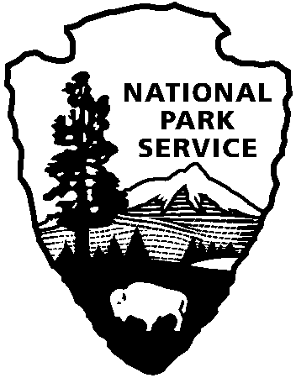

National Capital Parks - East
1900 Anacostia Drive SE
Washington, D.C. 20020
https://www.nps.gov/pisc/index.htm

(202) 690-5185
National Park Service
U.S. Department of the Interior

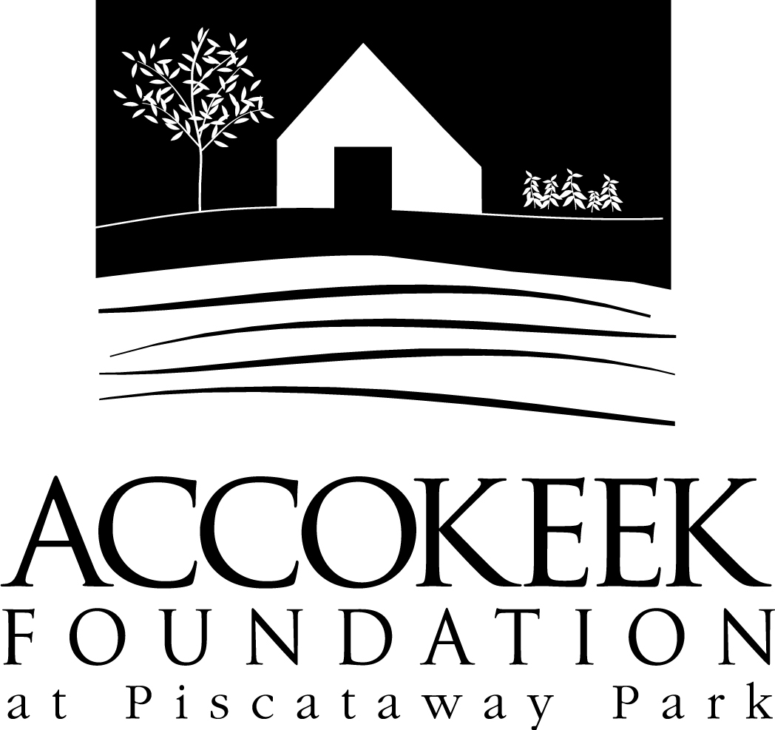

Position Title: Piscataway Park Stewards

About the Foundation:
By blending history, ecology, economics and conservation, the Accokeek Foundation strives to teach land stewardship and sustainable use of natural resources, as well as interpret the natural and cultural heritage of the Tidewater Potomac. The foundation’s mission is to cultivate passion for the natural and cultural heritage of Piscataway Park and commitment to stewardship and sustainability. The National Colonial Farm and other Foundation activities exemplify the agricultural, preservation and conservation goals that are at the core of the Foundation’s mission and serve as an outdoor classroom to further the educational programs that are key to its success. In partnership with the National Park Service, the Accokeek Foundation stewards a 200-acre portion of Piscataway Park and preserves the view directly across the Potomac River from Mount Vernon.

About National Capital Parks - East:
The administrative National Park Service unit of National Capital Parks – East (NACE) contains thirteen park units and parkways, including Piscataway Park. The overall unit consists of 98 locations and more than 8,000 acres of recreation areas, historic homes, natural areas, farms, parkways, historic forts, archeological sites, and private properties. The sites provide important green and recreation space amongst dense urbanization and educate visitors through stories and the historical information related to the area.

Purpose of the Piscataway Park Stewards Program:
Piscataway Park is open from dawn to dusk every day of the year, boasting a variety of visitor types and engagement levels. The Piscataway Park Stewards program was created to help support the Accokeek Foundation staff as they endeavor to provide the peak experience to each visitor through the day-to-day maintenance of the general grounds, structures, shorelines and trails, as well as preparation for site events and completion of projects.

Position Summary and Description of Duties: Through a cooperative agreement with the National Park Service, the Accokeek Foundation stewards 200 acres of Piscataway Park. Grounds Crew volunteers will assist staff with the day-to-day maintenance of the park and its facilities. Volunteers will take pride in ensuring that our visitors will have a safe experience here at Piscataway Park as they engage with the grounds, structures, shorelines, and trails.

Description of Duties:
Responsibilities may include:
- Ground maintenance such as mowing, weed whacking, mulching, and cleanup
- Trail maintenance
- Building upkeep such as cleaning, painting, and general repairs
- Trash cleanup in visitor areas/shoreline
- Cleaning/caring for onsite structures and spaces – can include reorganization
- Invasive removal in visitor spaces
- Maintenance and instillation of gardens/landscaping around buildings, walkways, and in dedicated visitor areas.
- Fence building, deconstruction, and repairs
- Basic building/repair of structures
- Site prep for public and private events
- Other duties as assigned.
Qualifications:
All skill levels and experience accepted, as a variety of projects will be involved. No previous experience is necessary, but volunteers should be comfortable working outdoors in varying weather conditions. Some lifting may be required. Experience with machinery, lawn care, structure repair, small engine care, and organization is a plus. Volunteers should be able to communicate questions, follow detailed instructions and training, and work in areas where visitors may be present.

Time Requirements:
Shifts are available throughout the year and will be scheduled based on need/projects. Regular volunteers will develop a schedule with the shift supervisor for shiftwork, and 1x volunteers will attend a ‘project day’ or volunteer call to support.

Benefits: Regular volunteers receive a complimentary membership to the Accokeek Foundation, which includes discounts on classes and events, a 10% discount in the Visitor Center, invitations to member and volunteer events, a discount on facility rental rates, and a copy of the newsletter.

Volunteers will also be enrolled in the National Park Service – wide Volunteers – In – Park (VIP) program by signing Volunteer Service Agreements. The VIP program protects those volunteering on National Park Service land in case of accident or injury through the Federal Employees’ Compensation Act and the Federal Tort Claims Act. Additionally, for every 250 hours served, volunteers are eligible to receive the America the Beautiful interagency pass which covers entrance fees to more than 2,000 federal recreation sites, including national parks and wildlife refuges, for one year.

Supervisor: Daniel Trott, Facilities and Grounds Manager, and Kaylin Beach, Volunteer Coordinator

To Apply:
Please contact Volunteer Coordinator, Kaylin Beach, at volunteer@accokeek.org.

