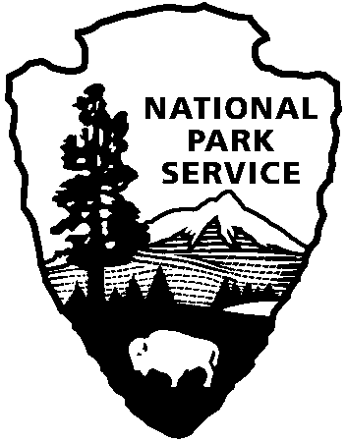

National Capital Parks - East
1900 Anacostia Drive SE
Washington, D.C. 20020
https://www.nps.gov/pisc/index.htm

(202) 690-5185
National Park Service
U.S. Department of the Interior

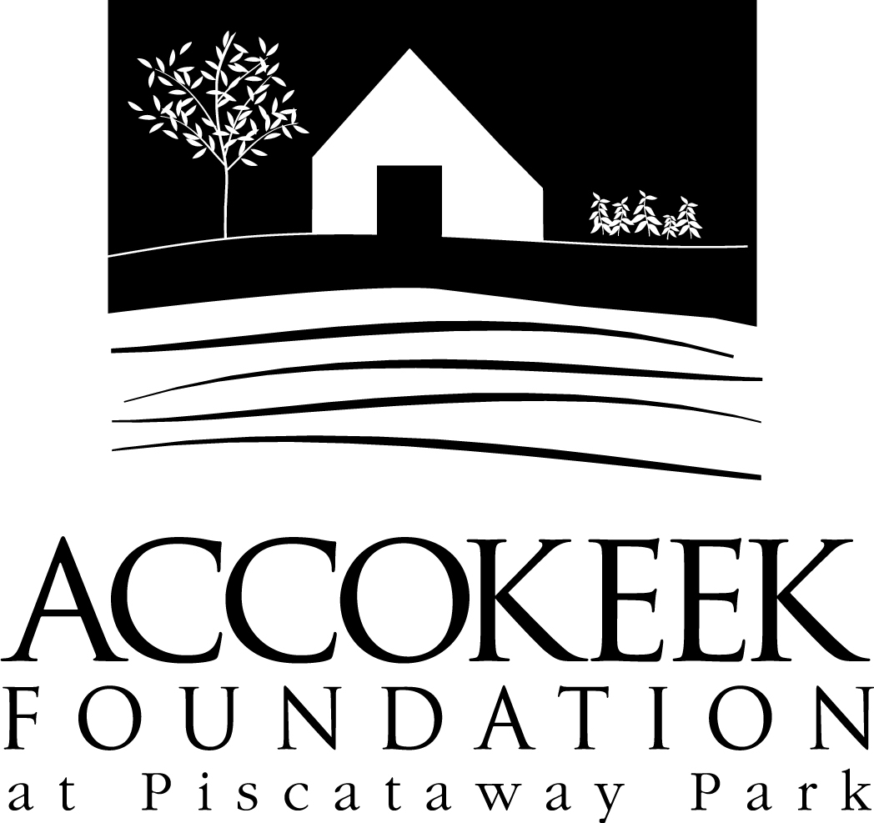

Position Title: Educational Support Team
About the Foundation:
By blending history, ecology, economics and conservation, the Accokeek Foundation strives to teach land stewardship and sustainable use of natural resources, as well as interpret the natural and cultural heritage of the Tidewater Potomac. The foundation’s mission is to cultivate passion for the natural and cultural heritage of Piscataway Park and commitment to stewardship and sustainability. The National Colonial Farm and other Foundation activities exemplify the agricultural, preservation and conservation goals that are at the core of the Foundation’s mission and serve as an outdoor classroom to further the educational programs that are key to its success. In partnership with the National Park Service, the Accokeek Foundation stewards a 200-acre portion of Piscataway Park and preserves the view directly across the Potomac River from Mount Vernon.

About National Capital Parks - East:
The administrative National Park Service unit of National Capital Parks – East (NACE) contains thirteen park units and parkways, including Piscataway Park. The overall unit consists of 98 locations and more than 8,000 acres of recreation areas, historic homes, natural areas, farms, parkways, historic forts, archeological sites, and private properties. The sites provide important green and recreation space amongst dense urbanization and educate visitors through stories and the historical information related to the area.

About the Accokeek Foundation Educational Support Team:

Position Summary and Purpose:
The Accokeek Foundation is seeking volunteers to help provide engaging educational programming and tours to the general public, school groups, rentals, and special event participants. Volunteers serving in this position will act as AF representatives and provide knowledgeable insight into the cultural, historical, and environmental factors that have shaped Piscataway Park, ensuring a positive and educational experience for guests.

Description of Duties:
Primary Responsibilities:
- Learn and provide various educational activities for special events and site programs (content may vary, room for specialization) including:
  - Perform as a special historical character for our school/weekend programming.
  - Learn and provide the general farm tour to students and the general public. Opportunity to wear 18th century period attire is available and encouraged, but not required.
  - Lead or support environmental education hikes, programs, activities alongside our staff on topics such as foraging/wildcrafting, animal tracking, sensory exploration/mindfulness, owls, or plant identification.
  - Other program support as needed.

Secondary Responsibilities:
- Learn and support various aspects of virtual programming, to include leading programs, management of technological program materials, support staff, guest presenters, virtual demos, etc... (room for specialization).
- Engage and educate visitors in all aspects of the park, including but not limited to: site orientation, membership and volunteer opportunities, special events, history, livestock, and natural resources
- May also include offsite tabling at events/program outreach if opportunities are available.
- Opportunities to help create new programming as appropriate.

Qualifications:
- Interest or knowledge of natural resources, outdoor skills, local history, or agriculture (training provided).
- Excellent customer service skills.
- Ability to speak in front of a group.
- Ability to multitask and problem solve.
- Excellent crowd management skills and a willingness to learn engagement strategies.
- Ability to read, learn, and present lesson plans, scripts, and demos of historical skills.
- Basic administrative skills including proficiency working with Microsoft Office and Google Docs.
- Excellent communication and organizational skills.
- Experience working with youth is preferred, but not required.
- Background check and fingerprinting is required for this position. The Foundation will cover the expense.
Time Requirements:
2-3 shifts per month is preferred. Programs are usually 2-4 hours, with special events shifts lasting longer. Our regular program season is from March-November, with occasional program shifts during the winter.

Benefits:
This position is an excellent way to build hard and soft skills in the areas of education and visitor engagement. Volunteers engaging in this position will have access to valuable training in public speaking, crowd management tactics, environmental education, cultural and historical education, content delivery methods and engagement strategies, etc... Volunteers will enjoy educating visitors in the beautiful outdoor classroom that is Piscataway Park. Volunteers will receive a 10% discount at the visitor’s center.

Volunteers will also be enrolled in the National Park Service – wide Volunteers – In – Park (VIP) program by signing Volunteer Service Agreements. The VIP program protects those volunteering on National Park Service land in case of accident or injury through the Federal Employees’ Compensation Act and the Federal Tort Claims Act. Additionally, for every 250 hours served, volunteers are eligible to receive the America the Beautiful interagency pass which covers entrance fees to more than 2,000 federal recreation sites, including national parks and wildlife refuges, for one year.

Supervisor:
Deanna Rishell, Public Programs Manager, and/or Kaylin Beach, School Programs Manager

To Apply:
Please contact Volunteer Coordinator Kaylin Beach at volunteers@accokeek.org.

