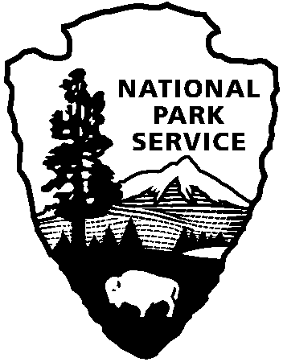

National Capital Parks - East
1900 Anacostia Drive SE
Washington, D.C. 20020
https://www.nps.gov/pisc/index.htm

(202) 690-5185
National Park Service
U.S. Department of the Interior

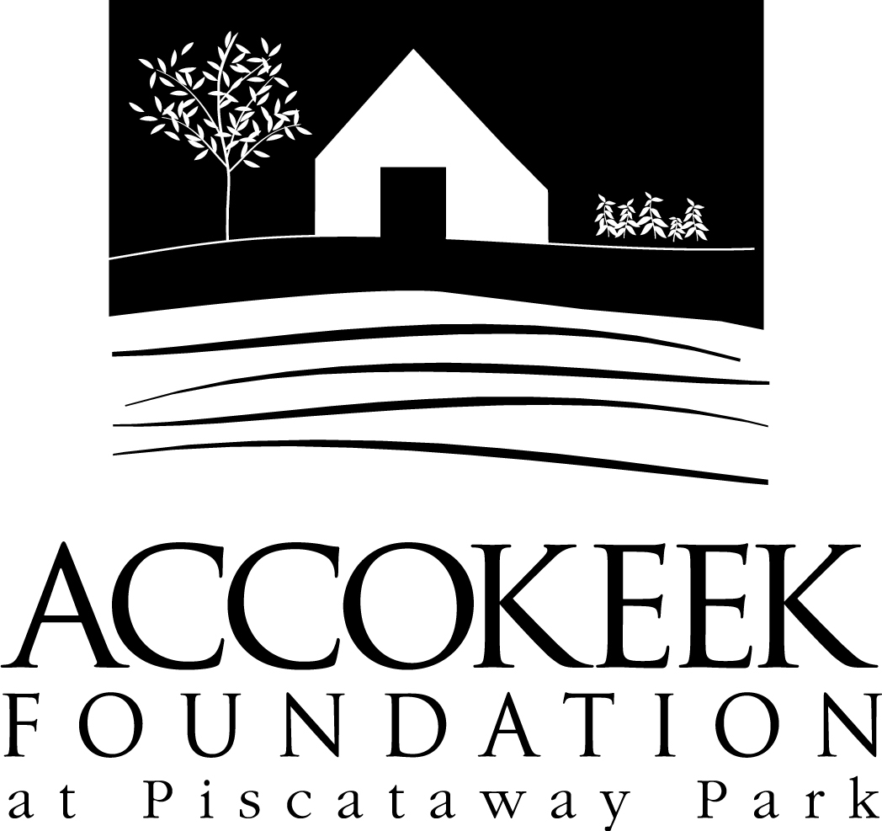

Position Title: Park Ambassador
About the Foundation:
By blending history, ecology, economics and conservation, the Accokeek Foundation strives to teach land stewardship and sustainable use of natural resources, as well as interpret the natural and cultural heritage of the Tidewater Potomac. The foundation’s mission is to cultivate passion for the natural and cultural heritage of Piscataway Park and commitment to stewardship and sustainability. The National Colonial Farm and other Foundation activities exemplify the agricultural, preservation and conservation goals that are at the core of the Foundation’s mission and serve as an outdoor classroom to further the educational programs that are key to its success. In partnership with the National Park Service, the Accokeek Foundation stewards a 200-acre portion of Piscataway Park and preserves the view directly across the Potomac River from Mount Vernon.

About National Capital Parks - East:
The administrative National Park Service unit of National Capital Parks – East (NACE) contains thirteen park units and parkways, including Piscataway Park. The overall unit consists of 98 locations and more than 8,000 acres of recreation areas, historic homes, natural areas, farms, parkways, historic forts, archeological sites, and private properties. The sites provide important green and recreation space amongst dense urbanization and educate visitors through stories and the historical information related to the area.

About the Accokeek Foundation Park Ambassador:
Park Ambassadors serve to greet visitors and enhance their visit during times when The Visitor Center is not open to guests. Ambassadors serve to answer visitor questions and enable visitors to experience Piscataway Park in a knowledgeable and memorable way. This volunteer position was created in response to COVID-19 closures and high park visitation as a way to safely provide general orientation, education, and to engage visitors about park safety and best practices for mitigating COVID-19 risk exposure. The hope was to encourage a deeper connection with nature and increase community engagement and stewardship of Piscataway Park. This position will continue to be offered until such a time as it is determined unsafe or the Visitor Center is reopened, with the potential of volunteers serving in this position being trained for the Visitor Center Representative position.

Position Summary and Purpose:
The Accokeek Foundation is seeking volunteers to help provide visitor orientation and engage with visitors outdoors during the March-November season. Volunteers serving in this position will act as AF representatives and provide front line customer service through visitor engagement, ensuring a positive orientation experience for guests.
Description of Duties:
- Engage and educate visitors in all aspects of the park, including but not limited to: site orientation, membership and volunteer opportunities, special events, history, livestock, and natural resources
- Track daily visitation data
- Answer inquiries
- Provide event support as needed
- Collect contact/solicit memberships
- Walk around the NCF/Barnyard areas to provide additional orientation and encourage appropriate park engagement
- Maintenance of table at station, inventory and report brochure needs.
- May also include offsite tabling/outreach if opportunities are available.

Qualifications:
- Excellent customer service skills
- Ability to multitask and problem solve
- Basic administrative skills including proficiency working with Microsoft Office and Google Docs.
- Excellent communication and organizational skills.
Time Requirements:
2-3 shifts per month is preferred. Shifts are 10-4, Saturday-Sunday, with a lunch break. Some flexibility in shift length and frequency is possible, depending on scheduling and availability. Additional shifts may be scheduled on holidays/during events to provide support.

Benefits:
Volunteers will also receive a 10% discount at the museum gift shop and visitor’s center.

Volunteers will also be enrolled in the National Park Service – wide Volunteers – In – Park (VIP) program by signing Volunteer Service Agreements. The VIP program protects those volunteering on National Park Service land in case of accident or injury through the Federal Employees’ Compensation Act and the Federal Tort Claims Act. Additionally, for every 250 hours served, volunteers are eligible to receive the America the Beautiful interagency pass which covers entrance fees to more than 2,000 federal recreation sites, including national parks and wildlife refuges, for one year.

Supervisor:
MaryAlice Bonomo, Visitor Services Manager

To Apply:
Please contact Volunteer Coordinator Kaylin Beach at volunteers@accokeek.org.

