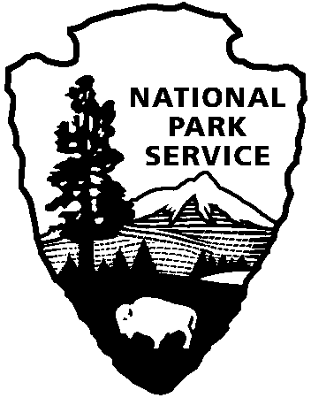

National Capital Parks - East
1900 Anacostia Drive SE
Washington, D.C. 20020
https://www.nps.gov/pisc/index.htm

(202) 690-5185
National Park Service
U.S. Department of the Interior

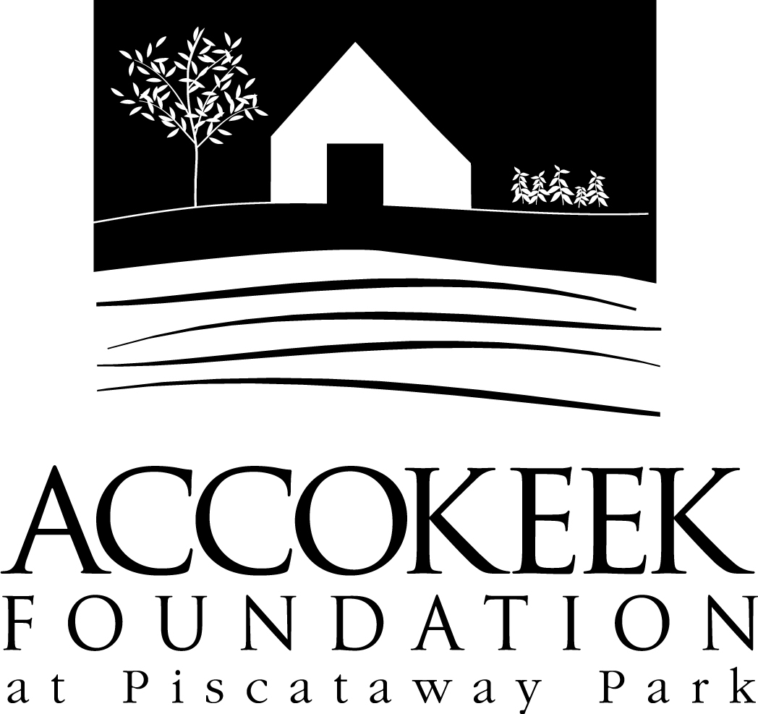

Position Title: Natural Resource Volunteer - Support Team

About the Accokeek Foundation:
A partner of the National Park Service in Piscataway Park, the Accokeek Foundation stewards 200 acres of park, including an 18th century historic demonstration farm, nature trails, Potomac River shoreline, forest, wetlands, and open pasture. By honoring the park’s river location, the Piscataway people, and the sacredness of this land, the Foundation seeks to share with people and communities through nature, agriculture, history, culture and foodways, the value that this land and soil hold, including evolving stories about different communities’ reliance on it for sustenance. Park visitors will experience the interconnectedness of all life as they come to know the historical and cultural significance and regenerative potential of the indigenous landscape that is Piscataway Park.

About National Capital Parks - East:
The administrative National Park Service unit of National Capital Parks – East (NACE) contains thirteen park units and parkways, including Piscataway Park. The overall unit consists of 98 locations and more than 8,000 acres of recreation areas, historic homes, natural areas, farms, parkways, historic forts, archeological sites, and private properties. The sites provide important green and recreation space amongst dense urbanization and educate visitors through stories and the historical information related to the area.

About the Citizen Science Program:
The citizen science program is part of the Accokeek Foundation’s stewardship of Piscataway Park. Many visitors appreciate the beauty of the park without realizing their important role in preserving this incredibly biodiverse set of ecosystems. As stewards of public lands, we protect and preserve the natural world while constantly growing our understanding of and modifying our impact on the world around us. As we document and catalog the incredible species around us, we are helping to advance science and grow our understanding of the direct correlation between our everyday actions and the direct responses seen in nature. Our Citizen Science Program includes Bluebird Monitoring, Invasive Plants Monitoring, Invasive Plants Removal, and Bioblitz programming.

Position Summary and Purpose:
The Natural Resource Volunteer Support Team will perform plant removals under National Park Service (NPS) compliance, plant native trees and shrubs, and survey priority ecosystems. Volunteers are invited to participate in invasive plant workshops offered by the Foundation. This position’s purpose is to manage the invasive plants on the 200 acres stewarded by the Accokeek Foundation, while also preparing volunteers through training/practice to engage in invasive plant management and removal in their own yards.

Description of Duties:

- Remove target species during removal events and shifts
- Document species removal via photo/data logging
- Properly install native plants
- Properly identify invasive plants during surveying events
- Properly dispose of removed invasive species to lower the chance of regrowth.
- Monitor areas of removal for new growth/note resurgence of species

Qualifications:
Volunteers acting in this position will need to have the physical capacity to remove plants by hand (pruning, pulling, cutting) as well as the ability to walk on varying ground types and over semi-long distances. Volunteers should be familiar with Microsoft Office software (Word, Excel) and be able to use these programs at an intermediate level. Skills such as self-direction, detail oriented, capable of interacting with general visitors in a personable and courteous way, and willing to take initiative are expected. Volunteers must own a smartphone with access to an app store (Apple or Android), and be willing to download apps appropriate to plant identification/removal as requested by supervisor.

Time Requirements:
This position requires a monthly shift commitment of 2-4 hours. Shifts are flexible and will be scheduled according to volunteer availability and invasive management pre-identified needs. At the discretion of the Volunteer Supervisor, more frequent shifts may be scheduled.

Benefits:
This volunteer position is an excellent educational opportunity. Volunteers will receive training in invasive plant identification, management, and mechanical removal (BMP’s) in accordance with National Park Service guidelines. Workshops will be offered throughout the year that volunteers in this position are encouraged to attend for additional skill development and content acquisition.

Volunteers will also be enrolled in the National Park Service – wide Volunteers – In – Park (VIP) program by signing Volunteer Service Agreements. The VIP program protects those volunteering on National Park Service land in case of accident or injury through the Federal Employees’ Compensation Act and the Federal Tort Claims Act. Additionally, for every 250 hours served, volunteers are eligible to receive the America the Beautiful interagency pass which covers entrance fees to more than 2,000 federal recreation sites, including national parks and wildlife refuges, for one year.

Supervisor:
Risharda Harley, Natural Resource Coordinator

To Apply:
Please contact Kaylin Beach at volunteers@accokeek.org.

